Student Activity Manager

System Report

Table of Contents:

1. Executive Summary. 3

2. Design Analysis Process 3

3. Entity Relationship Diagram 3

4. Table Designs – Data Dictionary 3

5. Contributions. 3

6. References 4

1. Executive Summary
2. Design Analysis Process
3. Entity Relationship Diagram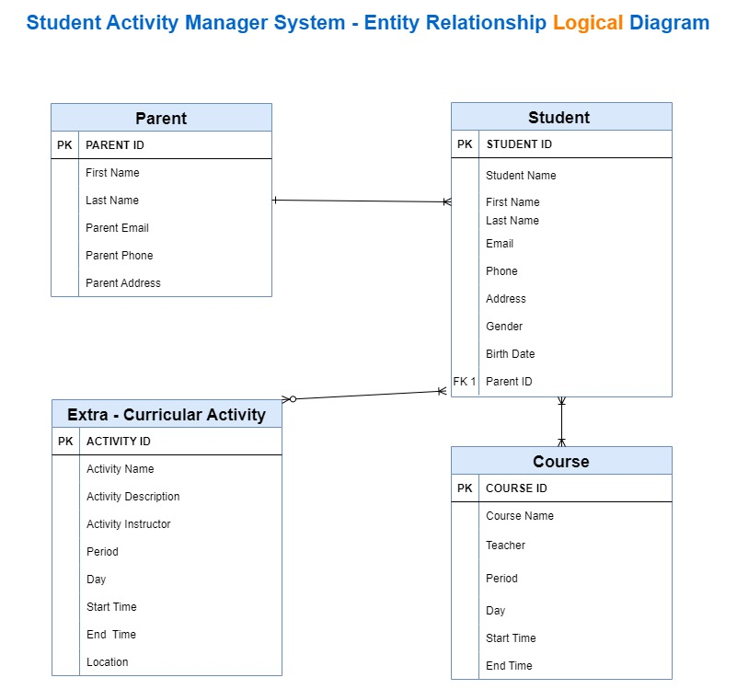

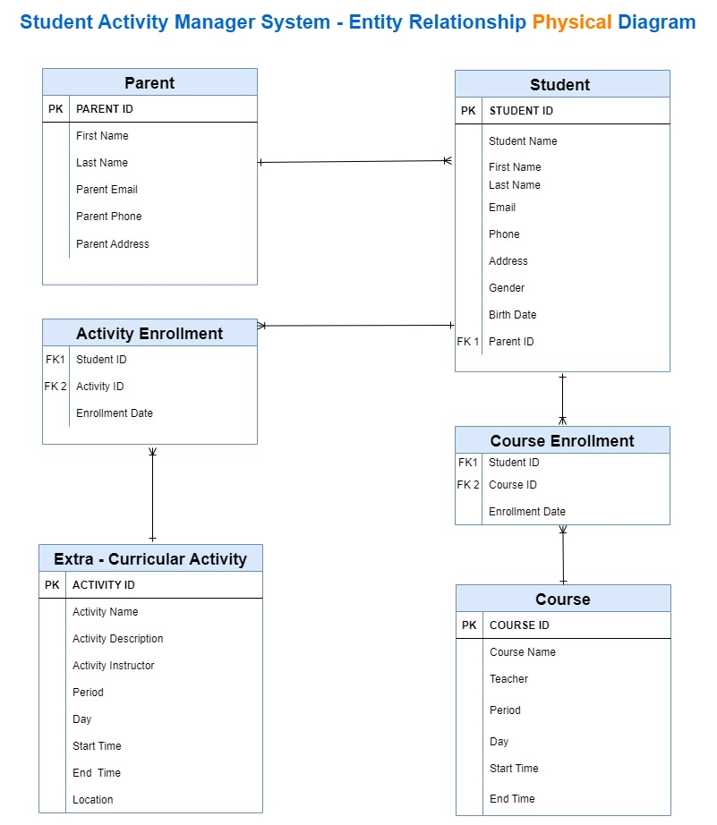

1. Table Designs – Data Dictionary

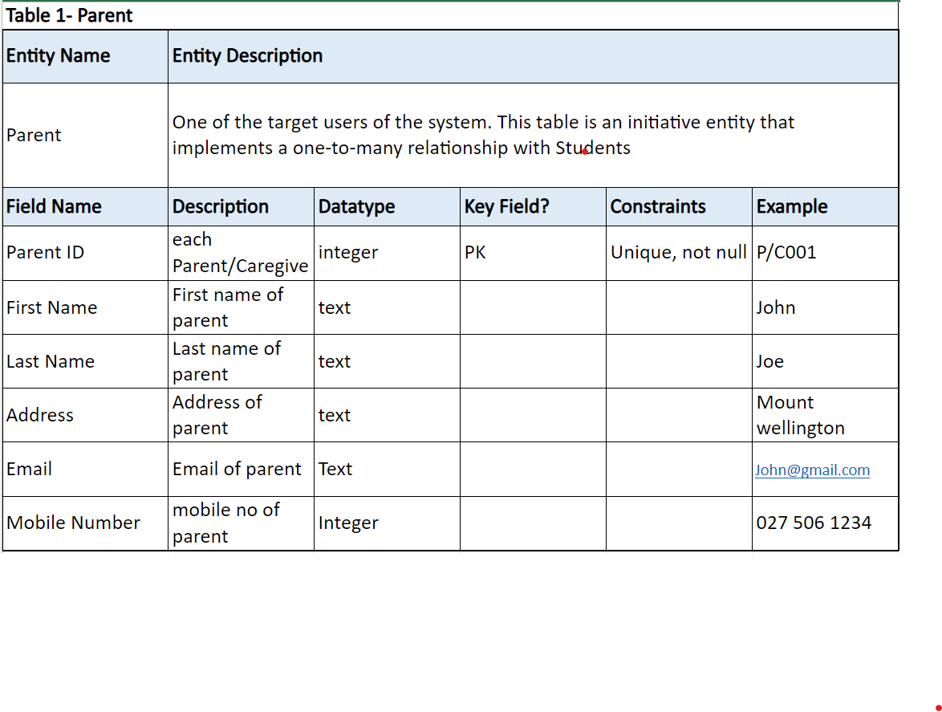

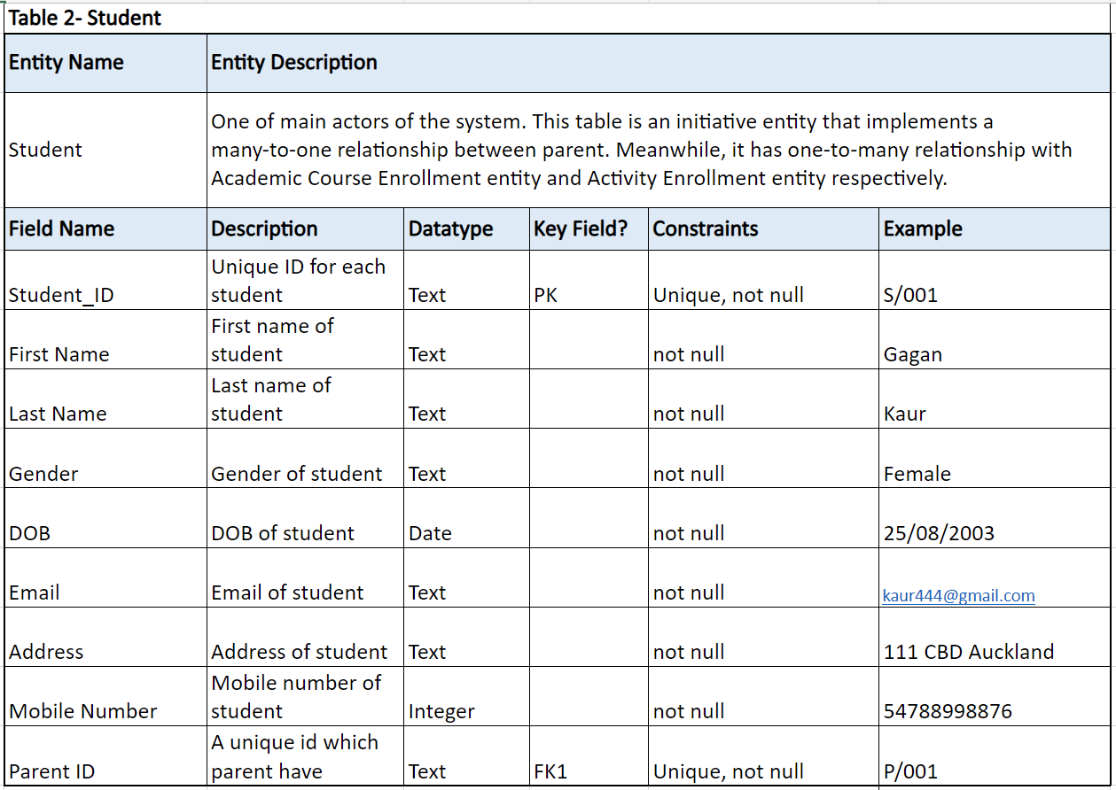

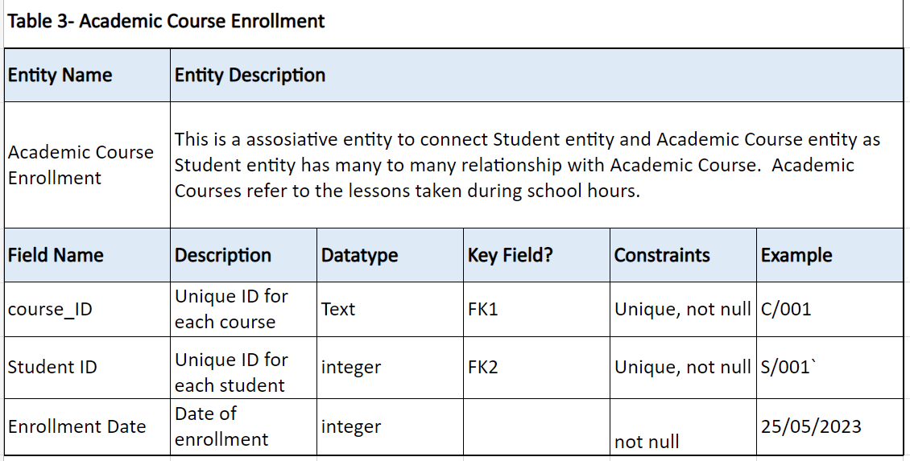

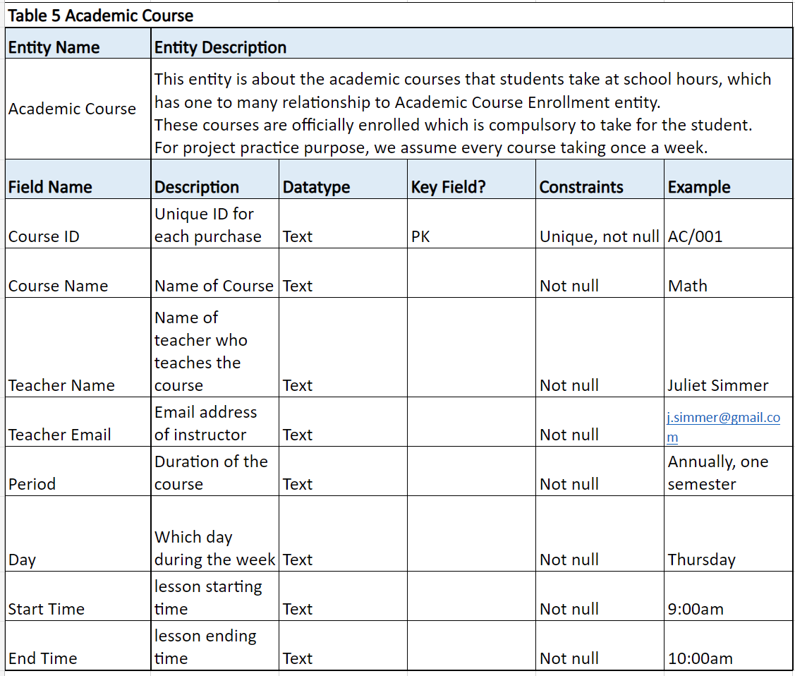

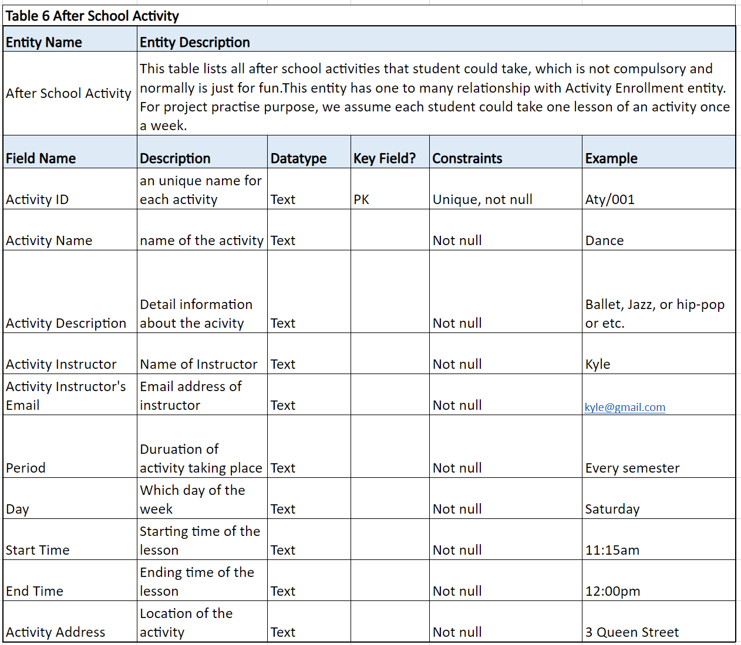

1. Contributions
2. References